Case Study Questions
- The required output for the main functionality is the letter code that is in accordance with the numeric input that is entered.
- The required input for the main functionality is the numeric float value that is taken in the function which will find the letter grade associated with the float numeric input.

Name of Widget in Python Code | Name of Widget in User Interface | Type of Widget | Description of Widget
convert_grade_input_button | Convert | button | The button is used to convert the numeric integer input. When the button is pressed it calls a function that will take the input stored in the entry box to obtain input and using the input convert it into a letter grade
entry_user_input | None | entry | The entry box is used to obtain the user input from the user interface and store it in a variable that will be used in the function to convert the input into a letter grade
clear_contents_button | Clear | button | This button is used call a function that will use to variables storing the entries and labels them by setting / configuring the result blank, or “”.
label_grade_result_display | None | Label | This label is used to display the result of the converted letter grade that is associated with the input
label_input_prompt_display | Enter Numeric Grade: | Label | This label is used to display the prompt or “title” of the entry box
label_grade_display | Converted Grade Letter: | Label | This label Is used to display the prompt that will

- 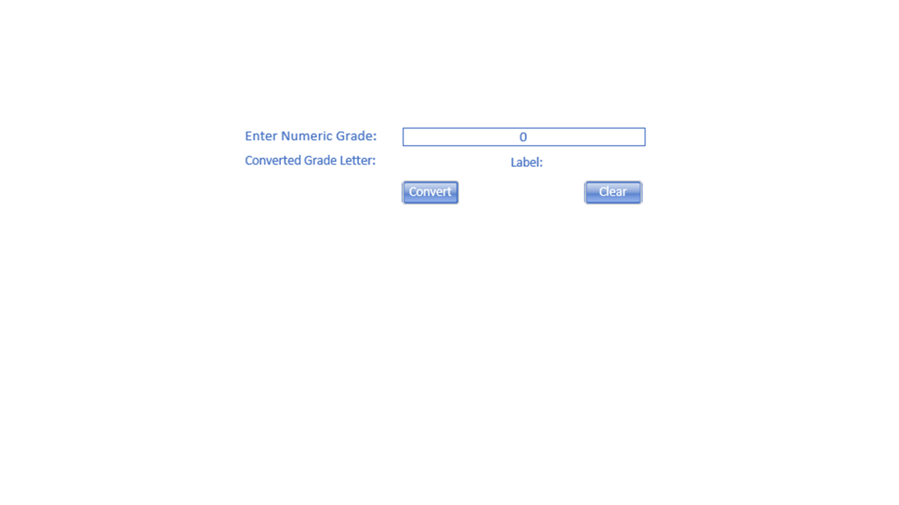

- Specific things:
- A non-contrast of colors is needed with the user interface window, for example if text is black, the background should be white, and not a dark grey colour.
- Hotkeys are a great accessibility tool that can make sure that the graphics user interface window is accessible. Possible hotkeys would be for Convert and Clear

